 | TEXT | TEXT | TEXT | TEXT | TEXT | TEXT
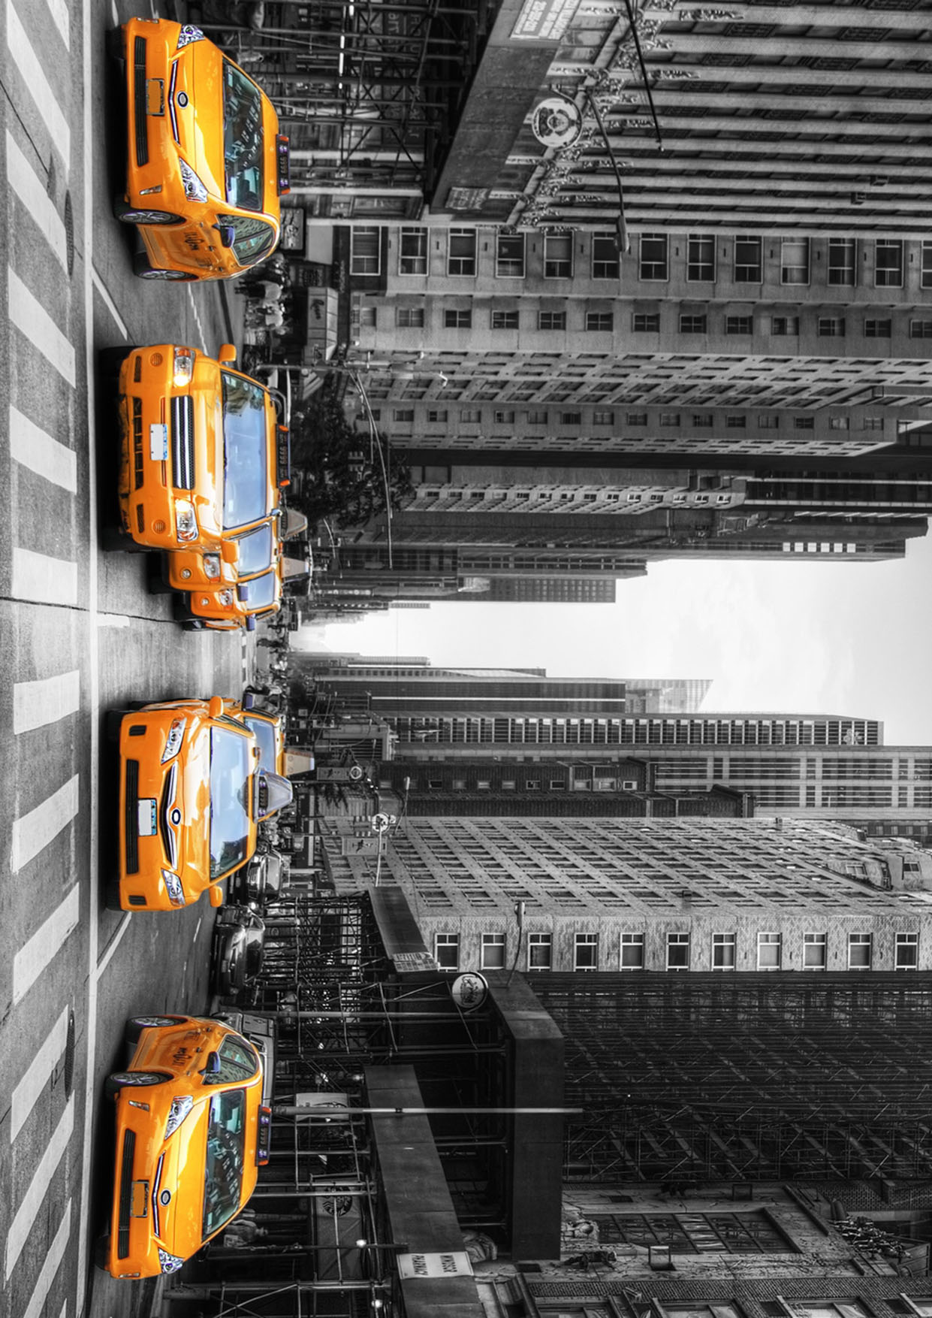
TEXT

