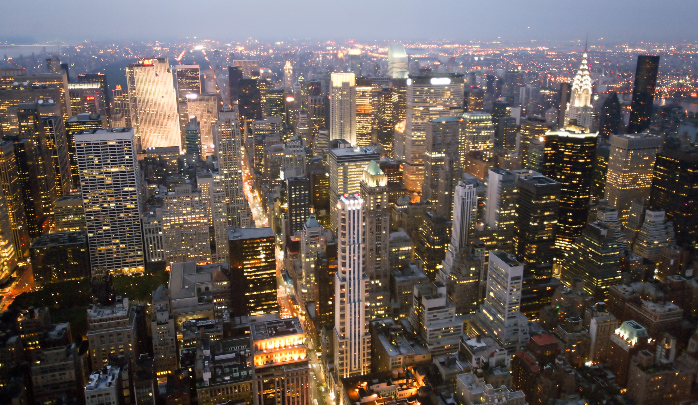 |  | TEXT  TEXT  TEXT  TEXT  TEXT  TEXT  TEXT

