  Max & Moritz  Address  Phone 00 000 00 00 | Max & Moritz  Address  Phone 00 000 00 00 | Max & Moritz  Address  Phone 00 000 00 00
Max & Moritz  Address  Phone 00 000 00 00 | Max & Moritz  Address  Phone 00 000 00 00 | 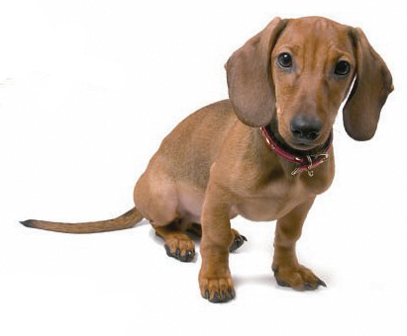  Max & Moritz  Address  Phone 00 000 00 00
  Felix  Address  Phone 00 000 00 00 | Felix  Address  Phone 00 000 00 00 | Felix  Address  Phone 00 000 00 00
Felix  Address  Phone 00 000 00 00 | Felix  Address  Phone 00 000 00 00 | Felix  Address  Phone 00 000 00 00
Paul  Address  Phone 00 000 00 00 | Paul  Address  Phone 00 000 00 00 | Paul  Address  Phone 00 000 00 00
Paul  Address  Phone 00 000 00 00 | Paul  Address  Phone 00 000 00 00 | Paul  Address  Phone 00 000 00 00
Laura  Address  Phone 00 000 00 00 | Laura  Address  Phone 00 000 00 00 | Laura  Address  Phone 00 000 00 00
Laura  Address  Phone 00 000 00 00 | Laura  Address  Phone 00 000 00 00 |   Laura  Address  Phone 00 000 00 00

