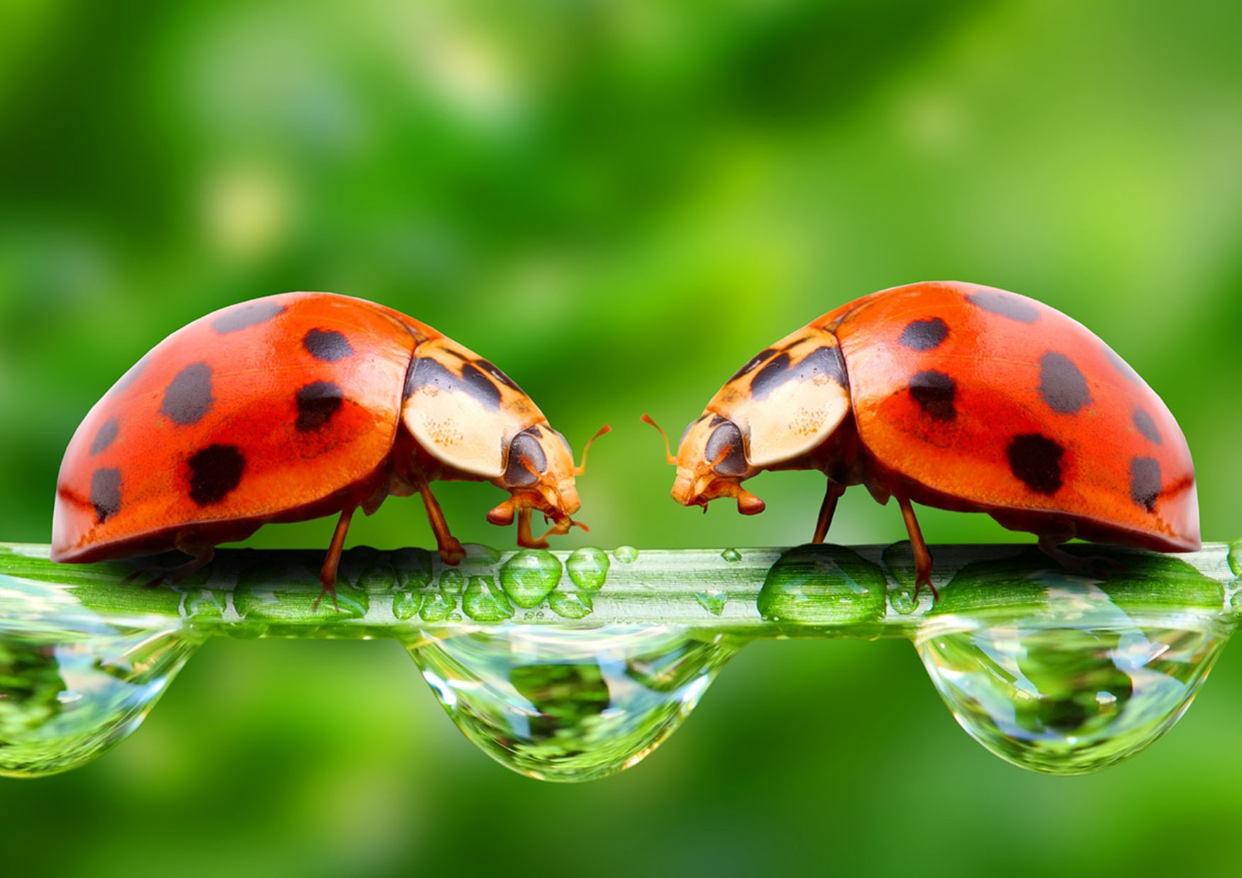 | TEXT | TEXT | TEXT | TEXT | TEXT | TEXT
TEXT

